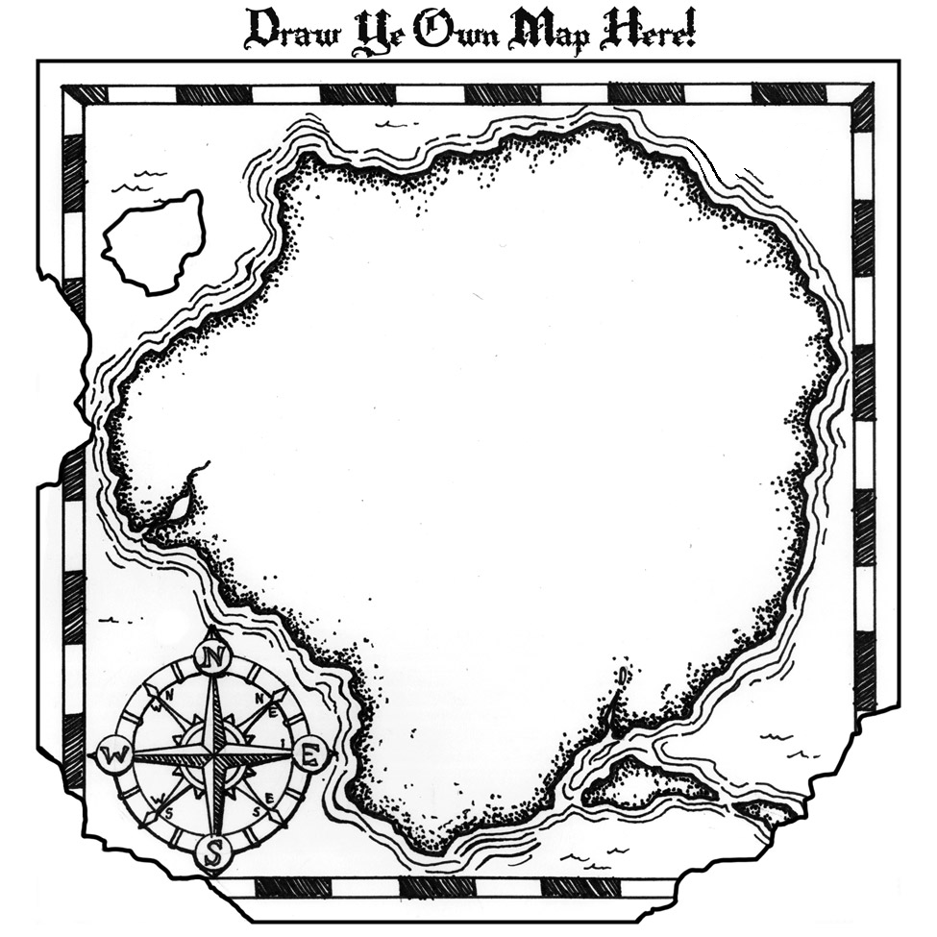

**#1:** [**Belin-Blank Center, Acceleration Institute**](http://www.accelerationinstitute.org/Nation_Empowered/Default.aspx)

Artifact: *A Nation Empowered: Vol. I.* Chapter 8:

“Educating the Educators”

**Acceleration –**

**Professional Development**

[**#5: Robinson Center for Young Scholars – University of Washington**](https://robinsoncenter.uw.edu/programs/professional-development/)

Artifact: Professional development opportunities for educators

**#3:** [**NAGC: NAGC-CEC Teacher Preparation Standards in Gifted Education**](http://www.nagc.org/resources-publications/resources/national-standards-gifted-and-talented-education/nagc-cec-teacher)

**# 4:** [**Washington Association for Educators of Talented and Gifted (WAETAG)**](http://www.waetag.net)

Artifact: Annual WAETAG Conference & resources for educators

**# 2:** [**Whitworth University Center for Gifted Education**](http://www.whitworth.edu/Academic/Department/Education/CenterForGiftedEducation/professional-development.html#page-content)

Artifact: Professional Development Opportunities