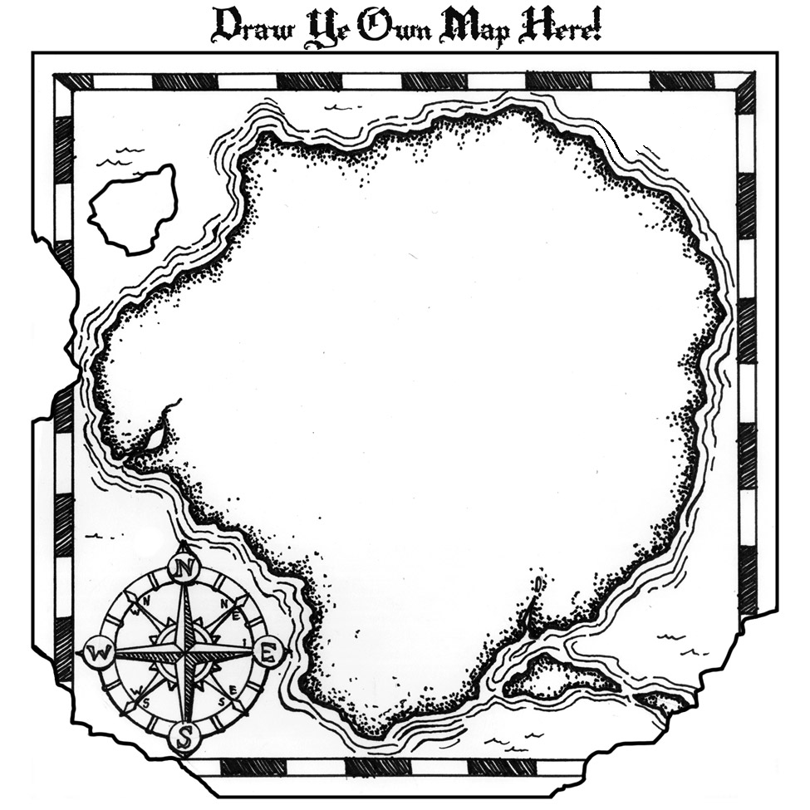

**#3:** [**Robinson Center for Young Scholars – University of Washington**](https://robinsoncenter.uw.edu/programs)

Artifact: Early Entrance Program & UW Academy for Young Scholars

**#2:** [**Hoagies’ Gifted Education Page**](http://www.hoagiesgifted.org/online_hs.htm)

Artifact: Resources for online education

**#1:** [**Stanford University Educational Program for Gifted Youth**](https://giftedandtalented.com)

Artifact: Advanced Learning Developed by Stanford University

(Related site: **Educational Program for Gifted Youth**)

**Acceleration:**

**Online, Distance Learning**