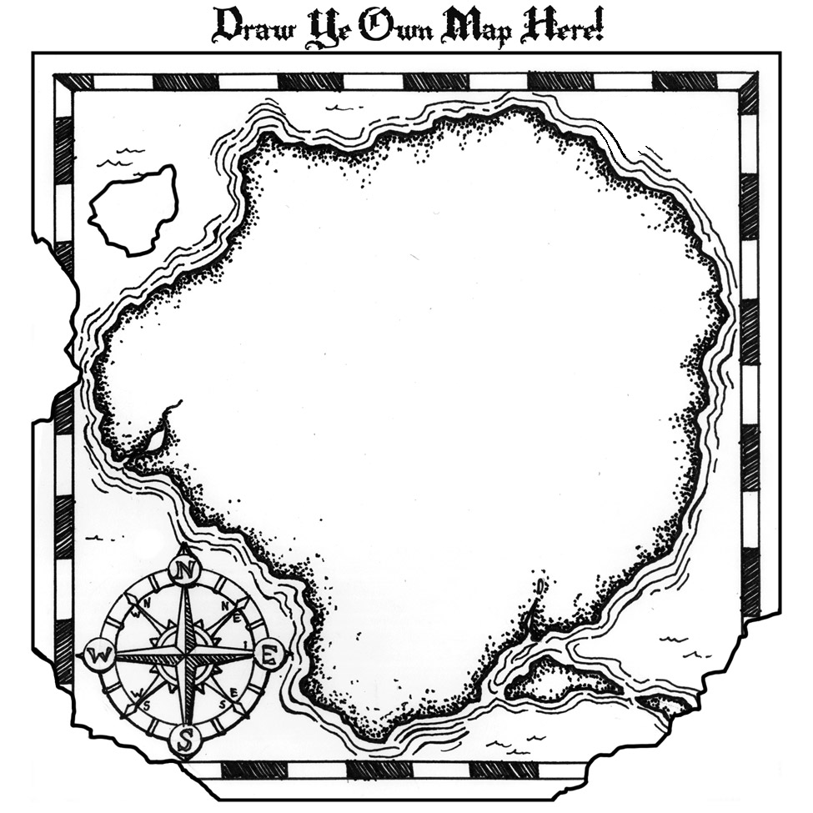

**#4:** [**NRC/GT (National Research Center/Gifted Talented**](http://www.gifted.uconn.edu/nrcgt/reports/rm99138/rm99138.pdf)

Artifact: Gentry Research on Cluster Grouping. Read Executive Summary

**#3:** [**Austin ISD, Gifted Education Program**](https://sites.google.com/a/austinisd.org/aisdaas/on-demand-presentations)**.**

Artifact: audio-video presentation on FLEXIBLE GROUPING

**#2:** [**Made for NAGC**](http://www.cmcgc.com/media/handouts/301111/203243.pdf)

Artifact: PowerPoint explaining Marcia Gentry’s *Schoolwide Cluster Grouping* model.

**#1:** [**NAGC Position Paper on GROUPING**](http://www.nagc.org/sites/default/files/Position%20Statement/Grouping%20Position%20Statement.pdf)

**ACCELERATION:   
Various Grouping Practices**