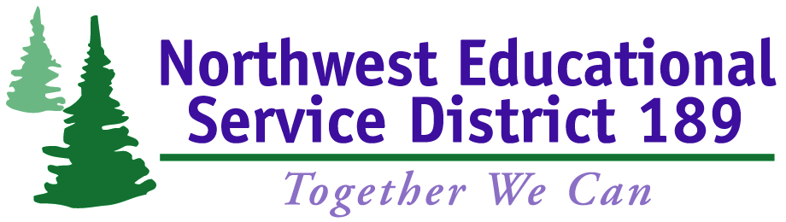

Department of Licensing (DOL) Examination Guidelines and Information

Washington State Department of Licensing (DOL) driver license knowledge and driving skills examinations are administered by qualified examiners in accordance with standards and procedures established by DOL. These examinations are conducted at Snohomish High School and Glacier Peak High School for students under the age of 18 who have successfully completed a Snohomish School District Traffic Safety Education (TSE) Program.

The fee to administer the initial driver licensing examinations (both written knowledge test and driving skills test) is $35 for students who completed TSE prior to January 2013. For students enrolled in TSE after January 2013, the DOL examination fee is included with the registration fee. All fees are nonrefundable.

The written knowledge exam consists of 25 multiple-choice questions about traffic safety laws. In order to pass the test, at least 20 answers must be correct. If the knowledge test is not passed the first time, there is an additional $25.00 for each subsequent test. Written knowledge tests are held in a group setting; rescheduling may be available for the next session.

The driving skills exam tests the student’s ability to drive legally and safely. A score of at least 80% is required to pass. If the driving skills test is not passed the first time, there is an additional $45.00 for each subsequent test. Driving skills tests are provided by appointment on an individual basis. Contact Marty Menzies if rescheduling is required.

Students must provide their own vehicle for the driving skills exam along with proof of insurance and current registration on the day of the test. The car must be legal to operate on public streets, including but not limited to, windshield, seat belts, wipers, defroster, tires, mirrors, all brake and reverse lights, turn signals, and licensed with current tabs. Arm signals will need to be demonstrated prior to beginning the skills test.

Exam scores are entered into the DOL database within twenty-four (24) hours. Passing the knowledge and driving tests does not guarantee that an applicant will be issued a driver license.

Visit a DOL office to apply for a driver license once all licensing requirements have been met. For students under the age of 18, requirements include:
- At least 16 years old
- Successful completion of a traffic safety education course
- Permit held for at least six (6) months
- Fifty (50) hours driving experience with at least ten (1) night driving hours

The DOL reserves the right to conduct random re-examinations; applicants refusing to take a re-examination may have their license revoked. Testing must be done at a DOL office if a letter was received from DOL regarding specific examinations due to a physical, mental, visual, or medical issue.

An online form is available to file complaints about the Traffic Safety Education (TSE) program or Department of Licensing (DOL) examination program administered by the Northwest Educational Service District 189 (NWESD).

---------------------------------------------------------------------------------
Contact Information:
Marty Menzies, Administrative Assistant
Email: Marty.Menzies@sno.wednet.edu or mmenzies@nwesd.org
Phone: (360) 563-4006

Joni Morrell, Administrative Assistant
Email: jmorrell@nwesd.org
Phone: (360) 299-4002

DOL charges additional application fees and licensing fees.

