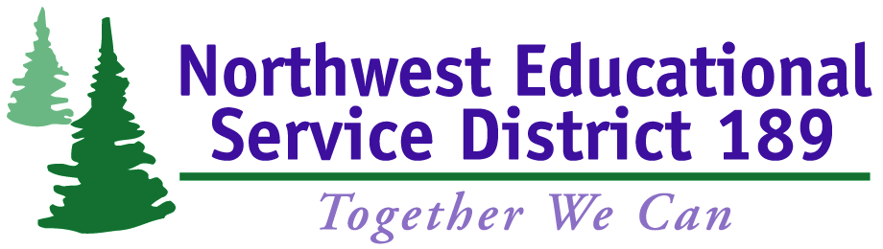

Traffic Safety Education (TSE) Guidelines and Expectations

Classroom Instruction.
In accordance with state requirements, students must attend 30 classroom hours; any time missed from class must be made up before a certificate can be issued. Missing more than two (2) classroom sessions without prior approval will result in failure of the class and forfeiture of registration fee. In order to pass the classroom portion, all assignments must be completed and all quizzes/tests passed with 80% or more correct.
If a student is dropped from the classroom or does not pass all assignments, quizzes, and/or tests within 30 days of the end of the TSE class, he/she will be required to pay the fee again and retake the entire course (both the classroom and driving components).
On-Street Driving Instruction.
Students should be able to complete the on-street portion of the program successfully in six (6) hours of instruction; additional on-street time is available for an added cost of $50 per hour. Students must demonstrate on-street skills required to obtain a driver’s license in order to pass the TSE course. Outside of class, a minimum of three (3) hours of practice on-street driving per week is required. This is especially important for those just beginning to learn to drive.
Missing more than one (1) on-street driving session will result in failure of the class and forfeiture of registration fee. If a student misses one (1) on-street driving session and has notified the instructor at least 24 hours before his/her driving session, there is no cost to the student. If a student misses a driving session without prior notification, he/she will be charged a $50 fee and the session must be made up. Any student who does not bring his/her permit to the on-street session may not drive and will be charged $50 for the missed session.
If a student is unable to pass the final drive test within 30 days of the end of the TSE class, he/she will be required to pay the fee again and retake the entire course (both the classroom and driving components).
The Washington Driver Guide is available online at http://www.dol.wa.gov/driverslicense/guide.html
---------------------------------------------------------------------------------
Contact Information:
Marty Menzies, Administrative Assistant
Email: Marty.Menzies@sno.wednet.edu or mmenzies@nwesd.org
Phone: (360) 563-4006

Joni Morrell, Administrative Assistant
Email: jmorrell@nwesd.org
Phone: (360) 299-4002

